**Offering price == $11.38 ;**  ; ; 

HPR ; ; **NAV1 = $20 × 1.08 × (1 – 0.01) = $21.384**

Trading Costs: 2*.004*.5 if transaction costs are .004 and turnover rate is 50% ;

**Determinants of Mutual Fund Flows:** Fund Flow = ; **Binomial Run:**  🡺 20,000(.5)^5=625 ; **20X Savings Rule:** 7-8% --return **minus** 2-3% --inflation =5% --spend rule; monthly interest rate: (1.05)^(1/12)-1 =.004074 or .4074%

Approximation: ; ; ;

; E(r) =(.25*.31)+(.45*.14)+{.25*(-.0675)}+{.05*(-.52)} = .0976 ;

;

Covariance = ; Covariance= .5(7%-6%)(25%-10.5%)+.3(-5%-6%)(10%-10.5%)+.2(20%-6%)(-25%-10.5%)=-90.5

–use .005 if returns in %, use 1/2 if returns in decimal form.;

**CAL**: Slope is Sharpe Ratio, Y-intercept is the risk-free rate; Y=return; X=SD; **Sharpe**: ; How much fee to make it equal to passive port:  **=SharpeofPassive;**

Thinking of switching 70% to passive: E(new) ;

Geometric Average = Arithmetic Avg – (1/2)*variance

Terminal Wealth: =(1.05)(1-.27)(1.08)(1-.03)(1-.01) = .795 => geometric return: (.795)^(1/5)-1 = -4.49%

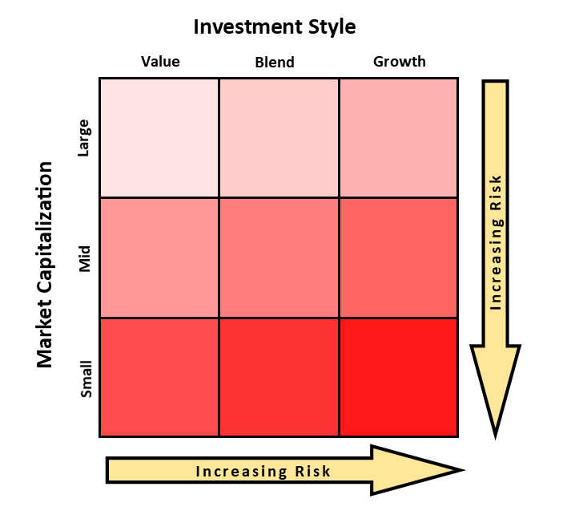Simple t Test: => =-.3224 ; Paired t Test: => =-.84; if

**Beta of an asset to a benchmark =** correlation * (volatility of the asset / volatility of the benchmark);

Borrow at the Risk-Free Rate and invest in stock.

Using 50% Leverage,

rc = (-.5) (.07) + (1.5) (.15) = .19

Weights sum to 1: -.5 + 1.5 = 1

sc = (1.5) (.22) = .33

Lower Sharpe ratio for the borrower

**S = .27=(15-9)/22**

AB: Long-term bond; AU: Gold oriented; BL: Balanced; EI: Equity Income; EM: Emerging Markets; EU: European region; GL: Global stock; GM: General muni; GT: General US taxable; HB: Health biotech; HC: High yield taxable; HM: High Yield municipal; IB: Intermediate bond; IG: Intermediate US gov’t; IL: International stock; IM: Intermediate muni; LC: Large cap core; LG: Large cap growth; LT: Latin American; LU: Long-term US; LV: Large cap value; MC: Mid cap core; MG: Mid-cap growth; MP: Multipurpose stock/bond blend

In general, a growth-oriented fund will hold the stocks of companies that the portfolio manager believes will increase earnings faster than the rest of the market. A value-oriented fund contains mostly stocks the manager thinks are currently undervalued in price and will eventually see their worth recognized by the market. A blend fund might be a mix of growth stocks and value stocks, or it may contain stocks that exhibit both characteristics.

Understanding how different types of stocks behave is crucial for building a diversified, style-controlled portfolio of stocks or mutual funds. The Morningstar Style Box helps investors construct portfolios based on the characteristics-the style factors-of all the stocks and funds that portfolio includes.

3. The Carhart four-factor model:



The intercept in this model is referred to as the “four-factor alpha”

Where EXRt is the monthly return to the asset of concern in excess of the monthly t-bill rate. We typically use these three models to adjust for risk. In each case, we regress the excess returns of the asset on an intercept (the alpha) and some factors on the right hand side of the equation that attempt to control for market-wide risk factors. The right hand side risk factors are: the monthly return of the CRSP value-weighted index less the risk free rate (EXMKT), monthly premium of the book-to-market factor (HML) the monthly premium of the size factor (SMB), and the monthly premium on winners minus losers (UMD) from Fama-French (1993) and Carhart (1997).

A fund has excess returns if it has a positive and statistically significant alpha.

SMB is a zero-investment portfolio that is long on small capitalization (cap) stocks and short on big cap stocks. Similarly, HML is a zero-investment portfolio that is long on high book-to-market (B/M) stocks and short on low B/M stocks, and UMD is a zero-cost portfolio that is long previous 12-month return winners and short previous 12-month loser stocks.

**PERSISTENCE IN MUTUAL FUND performance** does not reflect superior stock-picking skill. Rather, common factors in stock returns and persistent differences in mutual fund expenses and transaction costs explain almost all the predictability in mutual fund returns. Only the strong, persistent underperformance by the worst-return mutual funds remains anomalous.

**We can invest in low-cost ETF’s or other style index funds and get the same results without paying the high fees that many of these funds charge!**

**Mutual Fund Performance**: An Empirical Decomposition into Stock-Picking Talent, Style, Transactions Costs, and Expenses: We use a new database to perform a comprehensive analysis of the mutual fund industry. We find that funds hold stocks that outperform the market by 1.3 percent per year, but their net returns underperform by one percent. Of the 2.3 percent difference between these results, 0.7 percent is due to the underperformance of nonstock holdings, whereas 1.6 percent is due to expenses and transactions costs. Thus, funds pick stocks well enough to cover their costs. Also, high-turnover funds beat the Vanguard Index 500 fund on a net return basis. Our evidence supports the value of active mutual fund management.

**There is some ability to beat the market, but managers appear to extract the rents!**

**The Mutual Fund Fee Puzzle**: Previous work shows large differences in fees for S&P500 index funds. We expand this work to compare fees across all US equity funds using two methods, regression-based pricing models and holdings-based fund matching, to control for fund heterogeneity. We find economically large, robust, persistent, and pervasive fee dispersion in the mutual fund industry. Importantly, fee dispersion exists among the largest funds (top TNA quintile) as well as among institutional funds. Most surprisingly, fee dispersion has noticeably increased over the last twenty years, even as the industry has experienced enormous growth in capital invested and the number of funds

**Changing Names with Style**: Mutual Fund Name Changes and Their Effects on Fund Flows: We examine whether mutual funds change their names to take advantage of current hot investment styles, and what effects these name changes have on inflows to the funds, and to the funds’ subsequent returns. We find that the year after a fund changes its name to reflect a current hot style, the fund experiences an average cumulative abnormal flow of 28%, with no improvement in performance. The increase in flows is similar across funds whose holdings match the style implied by their new name and those whose holdings do not, suggesting that investors are irrationally influenced by cosmetic effects.

**A new historical database for the NYSE 1815 to 1925: Performance and predictability:**  In this paper, we collect individual stock prices for NYSE stocks over the period 1815 to 1925 and individual dividend data over the period 1825 to 1870. We use monthly price and dividend information on more than 600 individual securities over the period to estimate a stock price index and total return series that extends virtually to the beginning of the New York Stock Exchange. We use this data to estimate the power of past returns and dividend yields to forecast future long horizon returns. We "found some evidence of predictability in sub-periods but little predictability over the long term. We estimate the time-varying volatility of the U.S. market over the period 1815 to 1925 and "found evidence of a leverage e!ect on risk. This new database will allow future researchers to test a broad range of hypotheses about the U.S. capital markets in a rich, untouched sample.

In that case, here are some investing suggestions for your investment life:

Invest in LOW fee index funds as a function of your risk tolerance.

Never, ever, attempt to time the markets. The markets will go way up and way down: Do NOTHING.

Max out tax-free savings accounts (IRA’s, 401, 403, 457, etc.)

“Optimal portfolio”: 33% S&P500, 33% small cap/value, 33% international equity, composed of LOW fee index funds. 100% in this portfolio? Less as you age.

Save as much as you can. 10-20% of your gross income? More?

If you absolutely must actively invest, limit active trading to 10% of your assets (this is your fun money).

In 4-5 decades you will likely be part of the envied “1%.” You should target a FV of your savings of 15-20X your desired annual income.

Money is not as important as you might think.

* + - Skewness – The degree of asymmetry of a distribution.
    - Kurtosis –The degree of peakedness of a distribution.

Stock returns are sometimes said to be “leptokurtotic” that is, peaked in the center with fat tails.