Percentage Rent Example
A tenant pays rent at 10.0% of gross sales. The lease is signed on a triple net basis. You anticipate this year’s gross sales to total $1,000,000. What is the annual scheduled rent for this year?

Answer
Expected Gross Sales $1,000,000
Percentage Rent Rate x 10.00%
Percentage Rent $100,000

Consumer Price Index Increase (CPI)
    - Example:
    - Year 1980 CPI Index = 82.4
    - Year 1981 CPI Index = 90.9
    - Increase for the following year = 10.32%
- Overage Rent Example

- A tenant’s base rent is set at $12,500 per month with an overage rent set at 2.5% of gross sales over $8,000,000. The lease is signed on a triple net basis. You anticipate this year’s gross sales to total $9,750,000. What is the annual scheduled rent for this year?

- Answer
- Expected Gross Sales $9,750,000
- Less: Overage Rate -$8,000,000
- Gross Sales Overage $1,750,000
- Overage Rate x 2.5%
- Overage Rent $43,750

- Base Rent $12,500 monthly
- X 12
- Annual Base Rent $150,000
- Overage Rent +$43,750
- Annual Scheduled Rent $193,750

Cost Recovery (Depreciation)
      - Commercial Properties = 39 years
        - 1/39 or 0.0256
      - Residential Properties = 27.5 years
        - 1/27.5 or 0.0364

- Formula – Comparison Sales (R_{o}). Hint - Remember IRV
  - Income (NOI) = Rate (Capitalization Rate) X Value (Sales Price)
    - Ro Derivation : Divide NOI by the Sales Price
      - As risk increases the Ro increases

- GIM: Sale Price/Gross Income
- EGIM: Sale Price/Effective Gross Income

Overage Rent Example
A tenant’s base rent is set at $14,500 per month with an overage rent set at 2.5% of gross sales over $9,000,000. The lease is signed on a triple net basis. You anticipate this year’s gross sales to total $10,500,000.
What is the annual scheduled rent for this year?
Expected Gross Sales $10,500,000
Less: Overage Rate $9,000,000
Gross Sales Overage $1,500,000
Overage Rate x 2.5%
Overage Rent $37,500.00

Monthly Base Rent $14,500
X 12
Annual Base Rent $174,000
Overage Rent + $37,500
Annual Scheduled Rent $211,500.00

- Corner to Interior
  - From #4 to #3
  - -40%
- Interior to Corner
  - From #3 to #4
  - +66.7%
- M-1 to C-2
  - From #5 to #4
  - +25%
- C-2 to M-1
  - From #4 to #5
  - -20%
- 1.0 acres to 0.5 acres
  - From #4 to #1
  - -28%
- 0.5 acres to 1.0 acres
  - From #1 to #4
  - +38.9%

- What is the value of Lot 6? (Use Sale #5)
  - Adjustments
    - Corner to Interior (-40%)
  - $100,000-40%=$60,000
Or
  - Old =$100,000
  - % Change = -40
  - Solve for New = $60,000

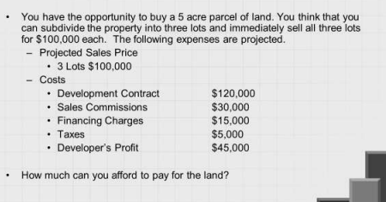
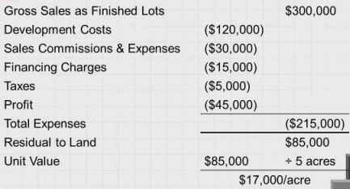
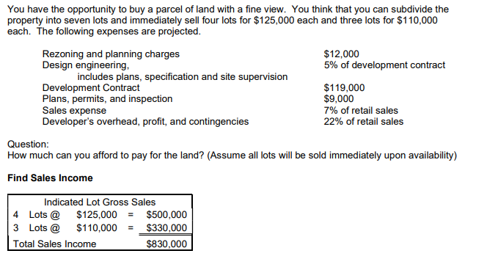

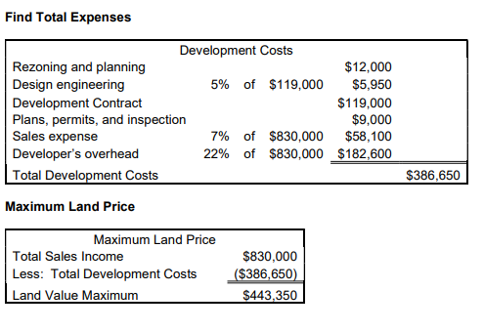
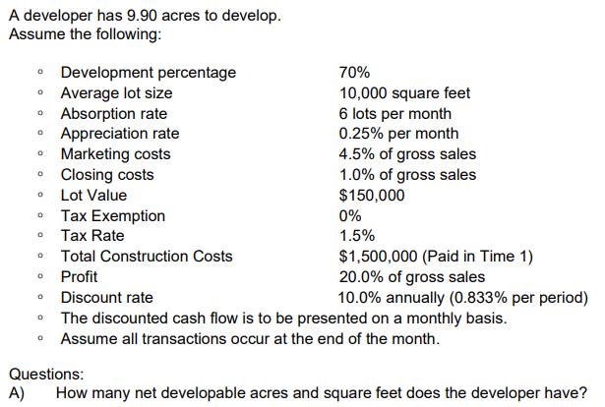

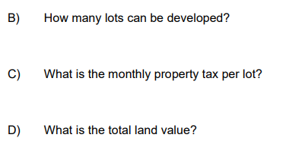
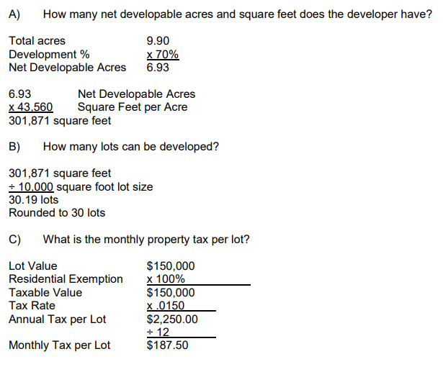
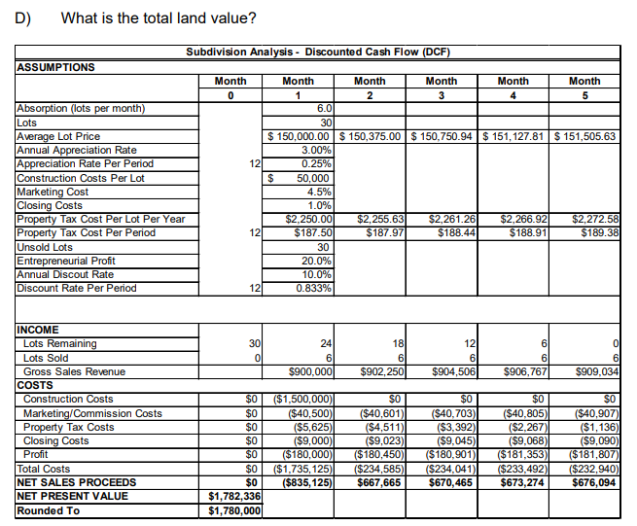
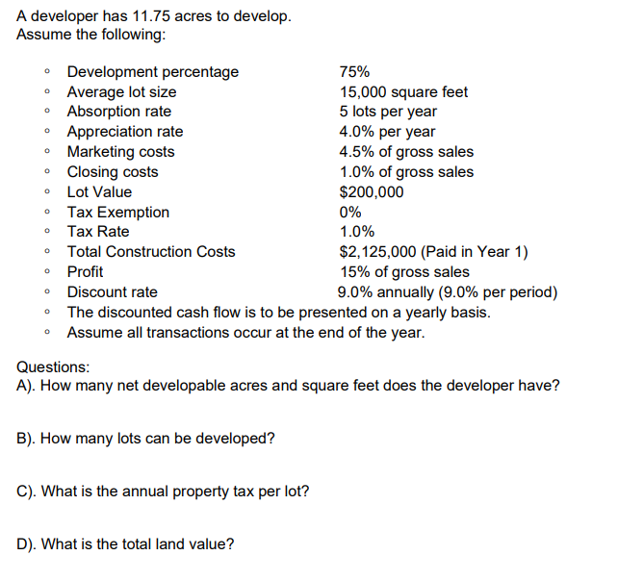

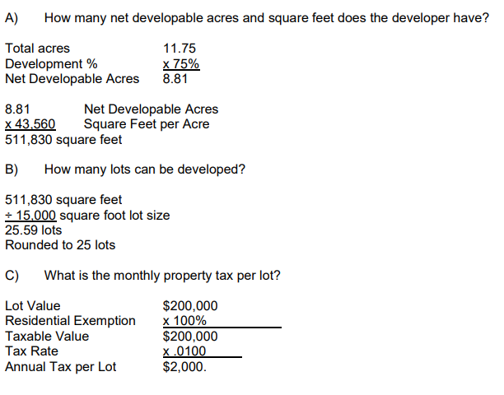

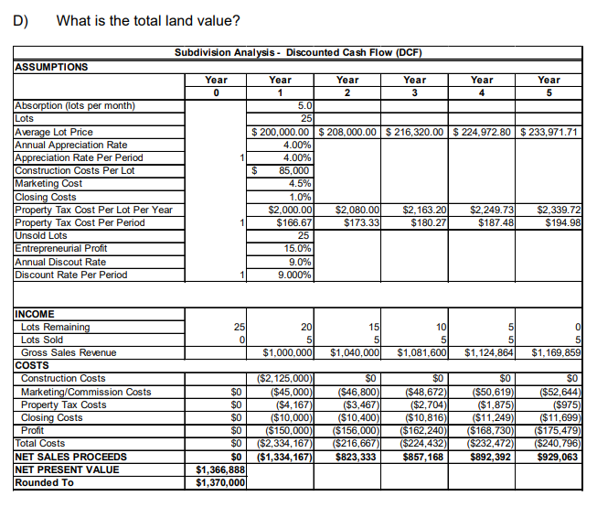

You found two sales to perform a Paired Sales Analysis (Matched Pair Analysis). Both sales are similar except for one attribute. Sale 1 sold for $110.40 per square foot one year ago while Sale 2 just sold for $113.93 per square foot. What is the percentage adjustment associated with this sale pertaining to market conditions (date of sale)? In other words, as a percentage, how much did the market increase during this period of time?

Answer on Screen 3.1975 or 3.20% Mathematical Solution New – Old / Old In this case, the amount of increase is being determined. How much did the market increase in one year. We want to know how much the market increased From (Old) one year ago To (New) today. The Old is the original price and the New is the most recent price. $113.93 - $110.40 / $110.40 = 0.0320 or 3.20%.

You want to know how much the consumer price index (CPI) changed from 2017 to 2018. The CPI in 2017 was 245.120 and the index in 2018 was 246.377. What is the percentage change during this period of time?

Answer on Screen 0.5128 or 0.51% Mathematical Solution New – Old / Old In this case, the amount of increase is being determined. How much did the CPI increase in one year. We want to know how much the market increased From (Old) one year ago To (New) today. The Old is the original price and the New is the most recent price. 246.377 – 245.120 / 245.120 = 0.0051 or 0.51%.

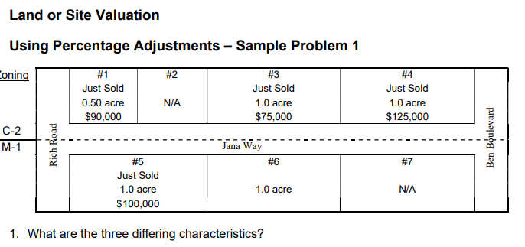
2. What are the following adjustments?
• From Corner to Interior
• From Interior to Corner
• From M-1 to C-2
• From C-2 to M-1
• From 1.0 acre to 0.5 acre
• From 0.5 acre to 1.0 acre
3. What is the value of Lot 6?

1. What are the three differing characteristics? Corner vs. Interior Block Parcels Zoning (M-1 vs. C-2) Land Size
2. What are the % adjustments for each factor?
Use Percent Change • Old • New • % Change
◦ From Corner to Interior #4 (old) to #3 (new) = -40.0%
◦ From Interior to Corner #3 (old) to #4 (new) = 66.7%
◦ From M-1 to C-2 #5 to #4(new) = 25.0% ◦ From C-2 to M-1 #4(old) to #5 (new) =- -20%
◦ From 1.0 acre to 0.5 acre #4 (old) to #1(new)= -28%
◦ From 0.5 acre to 1.0 acre #1(old) to #4(new)= 38.9% 3.
A. What is the Value of Lot 6? (Use Sale #5) ♣ Adjustments
◦ Corner to Interior (-40%) ♣ $100,000-40%=$60,000 Or ♣ Old =$100,000 ♣ % Change = -40 ♣ Solve for New = $60,000 B. What is the Value of Lot 6? (Use Sale #3) ♣ Adjustments
◦ C-2 to M-1(-20%) ♣ $75,000-20%=$60,000 Or ♣ Old =$75,000 ♣ % Change = -20 ♣ Solve for New = $60,000

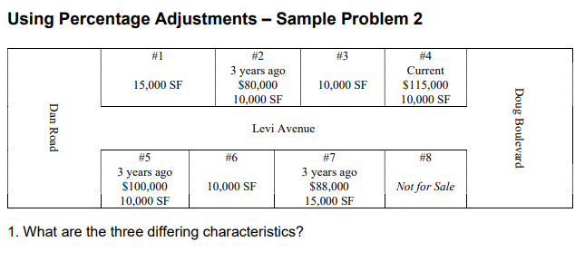
2. What is the percentage adjustment for each characteristic?
3. What is the value of Lot 6?
4. What is the value of Lot 1

