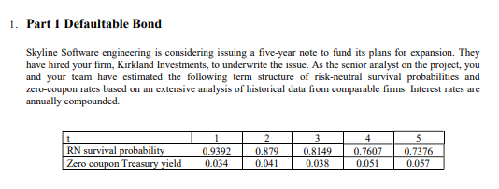
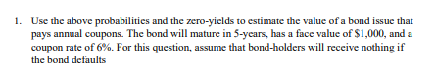
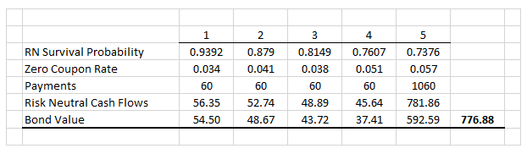
$$Coupon Payments=.06*1000=60$$
$$Final Payment= .06*1000+1000=1060$$
$$Risk Neutral Cash Flows: t_{1}=60*.9392=56.35$$
$$Risk Neutral Cash Flows: t_{2}=60*.879=52.74$$
$$Risk Neutral Cash Flows: t_{3}=60*.8149=48.89$$
$$Risk Neutral Cash Flows: t_{4}=60*.7607=45.64$$
$$Risk Neutral Cash Flows: t_{5}=1060*.7376=781.86$$
$${Bond Value}_{no recovery}=\frac{56.35}{{\left(1+.034\right)}^{1}}+\frac{42.74}{{\left(1+.041\right)}^{2}}\frac{48.89}{{\left(1+.038\right)}^{3}}\frac{45.64}{{\left(1+.051\right)}^{4}}\frac{781.86}{{\left(1+.057\right)}^{5}}=776.88$$

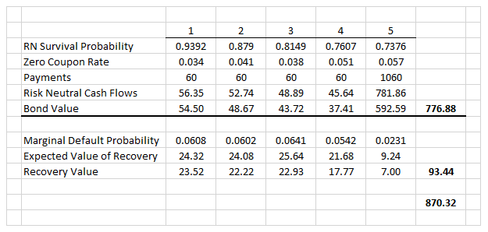
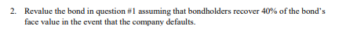
$$Bond Value With Recovery= V_{no recovery}+V_{recovery}$$
$${Marginal Default Probability}_{1}=1-.9392=.0608$$
$${Marginal Default Probability}_{2}=.9392-.879=.0602$$
$${Marginal Default Probability}_{3}=.879-.8149=.0641$$
$${Marginal Default Probability}_{4}=.8149-.7607=.0542$$
$${Marginal Default Probability}_{5}=.7607-.7376=.0231$$

$${Expected Value of Recovery}_{1}=.0608*.4*1000=24.32$$
$${Expected Value of Recovery}_{2}=.0602*.4*1000=24.08$$
$${Expected Value of Recovery}_{3}=.0641*.4*1000=25.64$$
$${Expected Value of Recovery}_{4}=.0542*.4*1000=21.68$$
$${Expected Value of Recovery}_{5}=.0231*.4*1000=9.24$$

$$Recovery Value=\frac{24.32}{{\left(1+.034\right)}^{1}}+\frac{24.08}{{\left(1+.041\right)}^{2}}\frac{25.64}{{\left(1+.038\right)}^{3}}\frac{21.68}{{\left(1+.051\right)}^{4}}\frac{9.24}{{\left(1+.057\right)}^{5}}=93.44$$
$$Bond Value With Recovery= V_{no recovery}+V_{recovery}$$
$$Bond Value With Recovery= 776.88+93.44=870.32$$
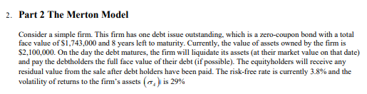
$$E=V_{t}N\left(d_{1}\right)-Ke^{-rT}N\left(d_{2}\right)$$
$$d_{1}=\frac{\ln\left(\frac{V_{t}}{K}\right)+\left(r+\frac{1}{2}σ_{v}^{2}\right)T}{σ_{v}\sqrt{T}}$$
$$d_{2}=d_{1}-σ_{v}\sqrt{T}$$

V = 2,100,000
K = 1,743,000
T = 8
R = .038
$σ_{v}$= .29
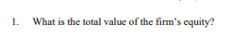
$$d_{1}=\frac{\ln\left(\frac{2,100,000}{1,743,000}\right)+\left(.038+\left(.5\right)*{.29}^{2}\right)8}{.29\sqrt{8}}=1.0079$$
$$d_{2}=1.0079-.29\sqrt{8}= .1877$$
$$Equity=2,100,000*.8433-1,743,000e^{\left(-.038*8\right)}*.5744=1,032,056.87$$
$$Debt=2,100,000-1,032,056.87=1,067,943.13$$

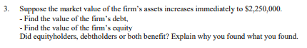
V = 2,250,000
K = 1,743,000
T = 8
R = .038
$σ_{v}$= .29
$$d_{1}=\frac{\ln\left(\frac{2,250,000}{1,743,000}\right)+\left(.038+\left(.5\right)*{.29}^{2}\right)8}{.29\sqrt{8}}=1.0920$$
$$d_{2}=1.0920-.29\sqrt{8}= .2718$$
$$Equity=2,250,000*.8626-1,743,000e^{\left(-.038*8\right)}*.6071=1,160,032.75$$
$$Debt=2,250,000-1,160,032.75=1,089,967.25$$

As firm value increases, all else being equal, there is a benefit to equity holders over that of debt holders, and the advantage widens as the firm value goes up.
This is because it is anticipated that as firm value increases, there will be more value available at the end of the firm’s life that can be used to cover debt obligations with the remaining profit being given to equity holders.
As I did an analysis of equity and debt values using the Merton Model and increasing firm value but holding all other variables constant, I found that both equity and debt holders benefit but at differing rates. For example, when moving from a firm value of 2.1MM to 2.25MM the value of the firm’s equity grew 12.4% while the value of the debt grew by only 2.1%. The Merton Model interprets the growth of the firm as being primarily that of equity because the debt portion of the firm’s balance sheet is contractual with a value that would stay relatively constant.
However, the Merton Model does indicate a slight increase in the value of the firm’s debt. I attribute this to a decrease in the probability of default as the firm’s value increases.
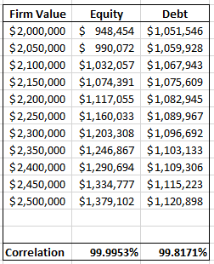
Although both equity and debt are almost perfectly correlated with increases in firm value, their slopes are quite different.
$$\frac{Δy_{e}}{Δx_{v}}=\frac{1,379,102-948,454}{2,500,000-2,000,000}=.86$$

$$\frac{Δy_{d}}{Δx_{v}}=\frac{1,120,898-1,051,546}{2,500,000-2,000,000}=.14$$
For every dollar increase in firm value, equity moves 86 cents and debt moves 14 cents.

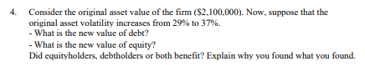
V = 2,100,000
K = 1,743,000
T = 8
R = .038
$σ_{v}$= .37
$$d_{1}=\frac{\ln\left(\frac{2,100,000}{1,743,000}\right)+\left(.038+\left(.5\right)*{.37}^{2}\right)8}{.37\sqrt{8}}=.9918$$
$$d_{2}=.9918-.37\sqrt{8}= -.0547$$
$$Equity=2,100,000*.8394-1,743,000e^{\left(-.038*8\right)}*.4782=1,147,654.93$$
$$Debt=2,100,000-1,160,032.75=952,345.07$$

Typically, stocks with high volatility have derivatives that are more likely to be profitable or in-the-money by expiry.
The Merton Model allows us to model a firm’s equity as a call option on its assets. Thus, when we increase the volatility of firm value, there is a positive correlation with the firm’s equity value. To be clear, at σ = 37%, equity benefits and debt doesn’t.
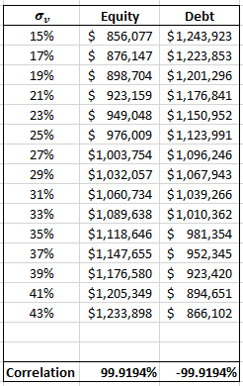
In this case, equity and debt have the same correlation except they are of opposite sign.

$$\frac{Δy_{e}}{Δx_{σ}}=\frac{1,233,898-856,077}{43\%-15\%}=13,493.61$$

$$\frac{Δy_{d}}{Δx_{σ}}=\frac{866,102-1,243,923}{43\%-15\%}=-13,493.61$$

Similarly, for every percentage increase in firm value volatility, equity moves up $13,493.61 and debt moves down ($13,493.61).

